**Data Engineering – Final Assessment**

**GITHUB REPOSITORY LINK:** [**GitHub**](https://github.com/hvsj/ML_Incubator_DE)

**TASKS:**

**Data Discovery, Processing, Loading Task:**

**Task 1**

1. Move the dataset onto S3.

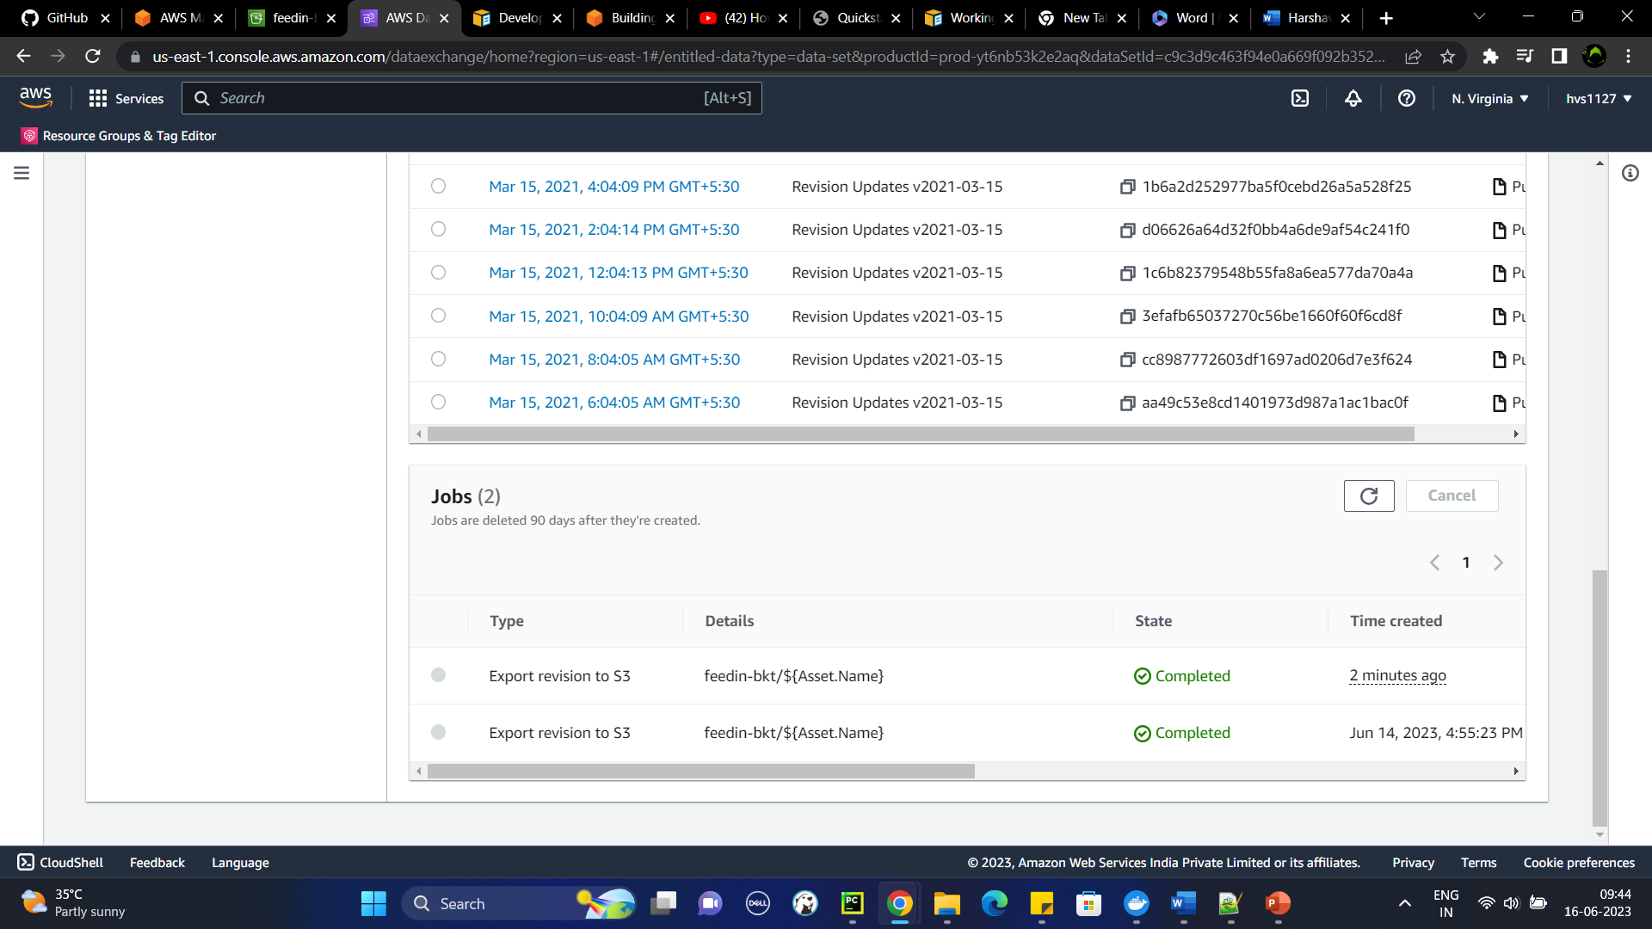

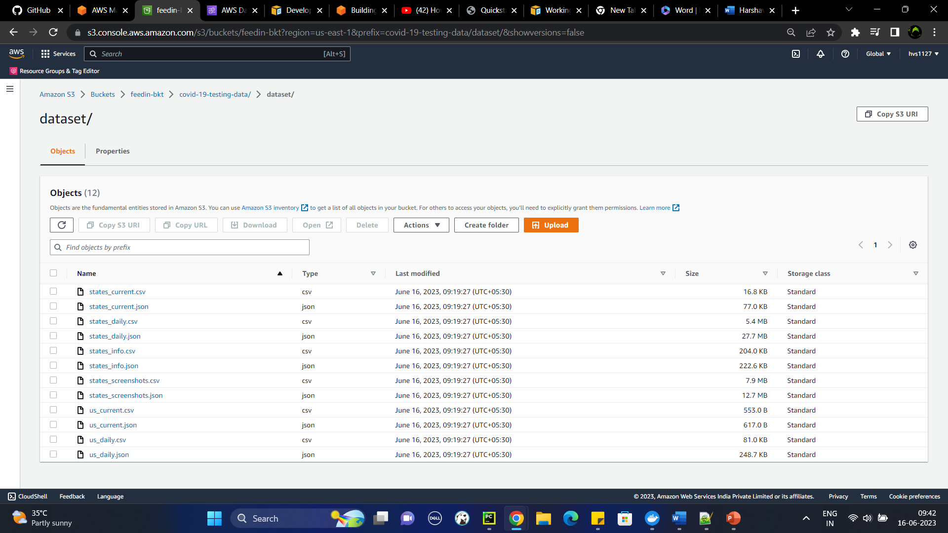

1. Create Glue database and 2 crawlers to crawl CSV and JSON folders using AWS CLI only, provide screen shots of using AWS CLI (Please note Console cannot be used to create Database and Crawlers)

**CMD:**

**To create a database through AWS CLI:**

>> *aws glue create-database –database-input “{\”Name\”:\”<database_name>\”, \”Description\”:\”This the database created from AWS CLI for ML Incubator DE Final Assement\”}” --profile <profile_name>*

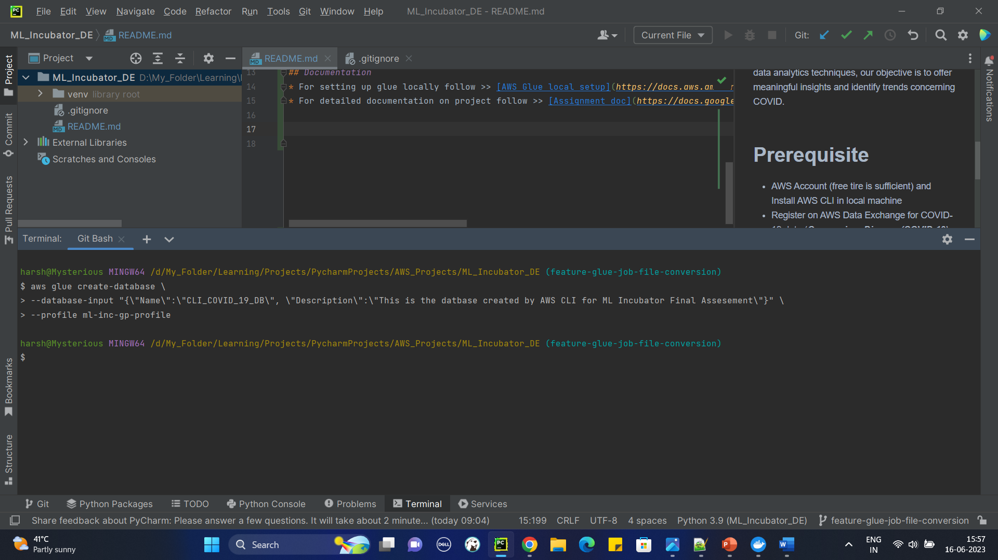

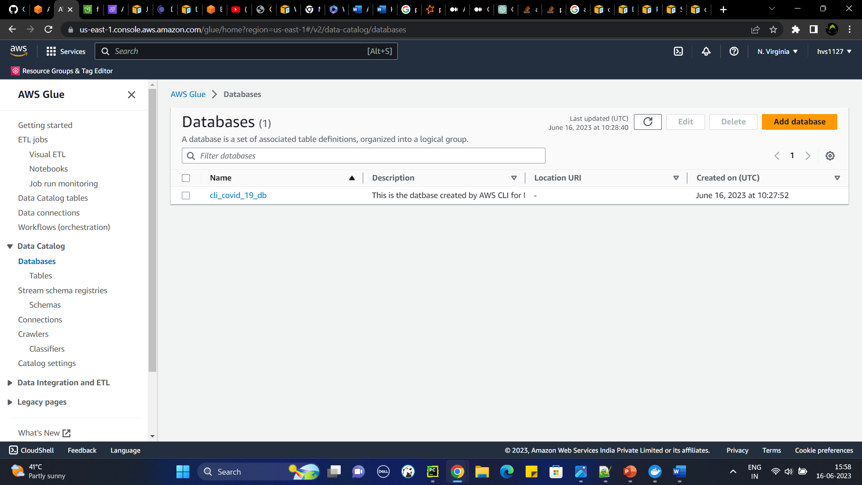

**To create a crawler through AWS CLI:**

>> *aws glue create-crawler --name <crawler_name> --role <glue_role_name> --database-name <database_name> --table-prefix <prefix> --targets “{\”S3Targets\”:[{\”Path\”:\”s3:\\<bucket_name>\<path_to_files>”, \” Exclusions\”:[<string_list>]} ]}”*

***Note: Since dataset is available in csv and json in same folder I have added additional parameter to each crawler to ignore the other file format***

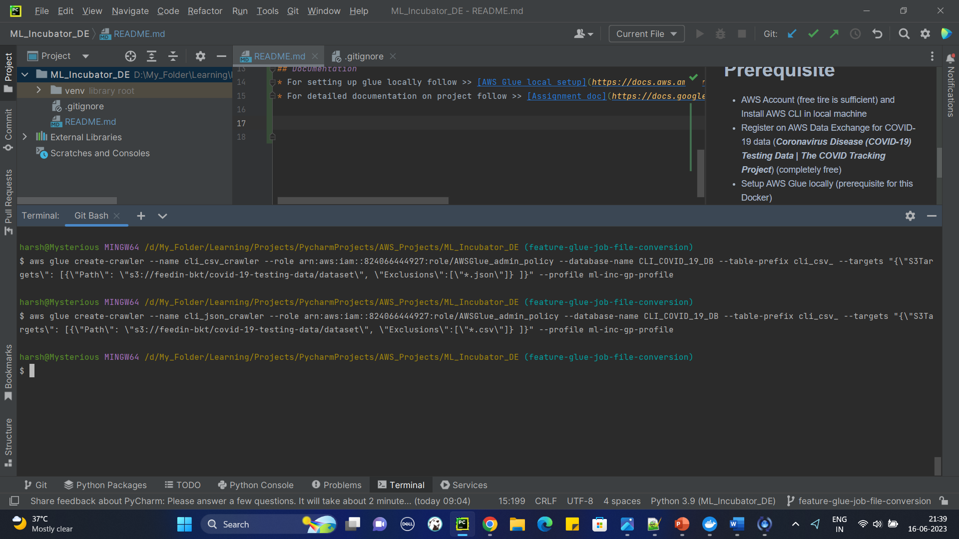

1. Run the Crawlers from CLI

**CMD:**

To run the crawler through AWS CLI:

>> ***aws glue start-crawler --name <name_of_the_crawler>***

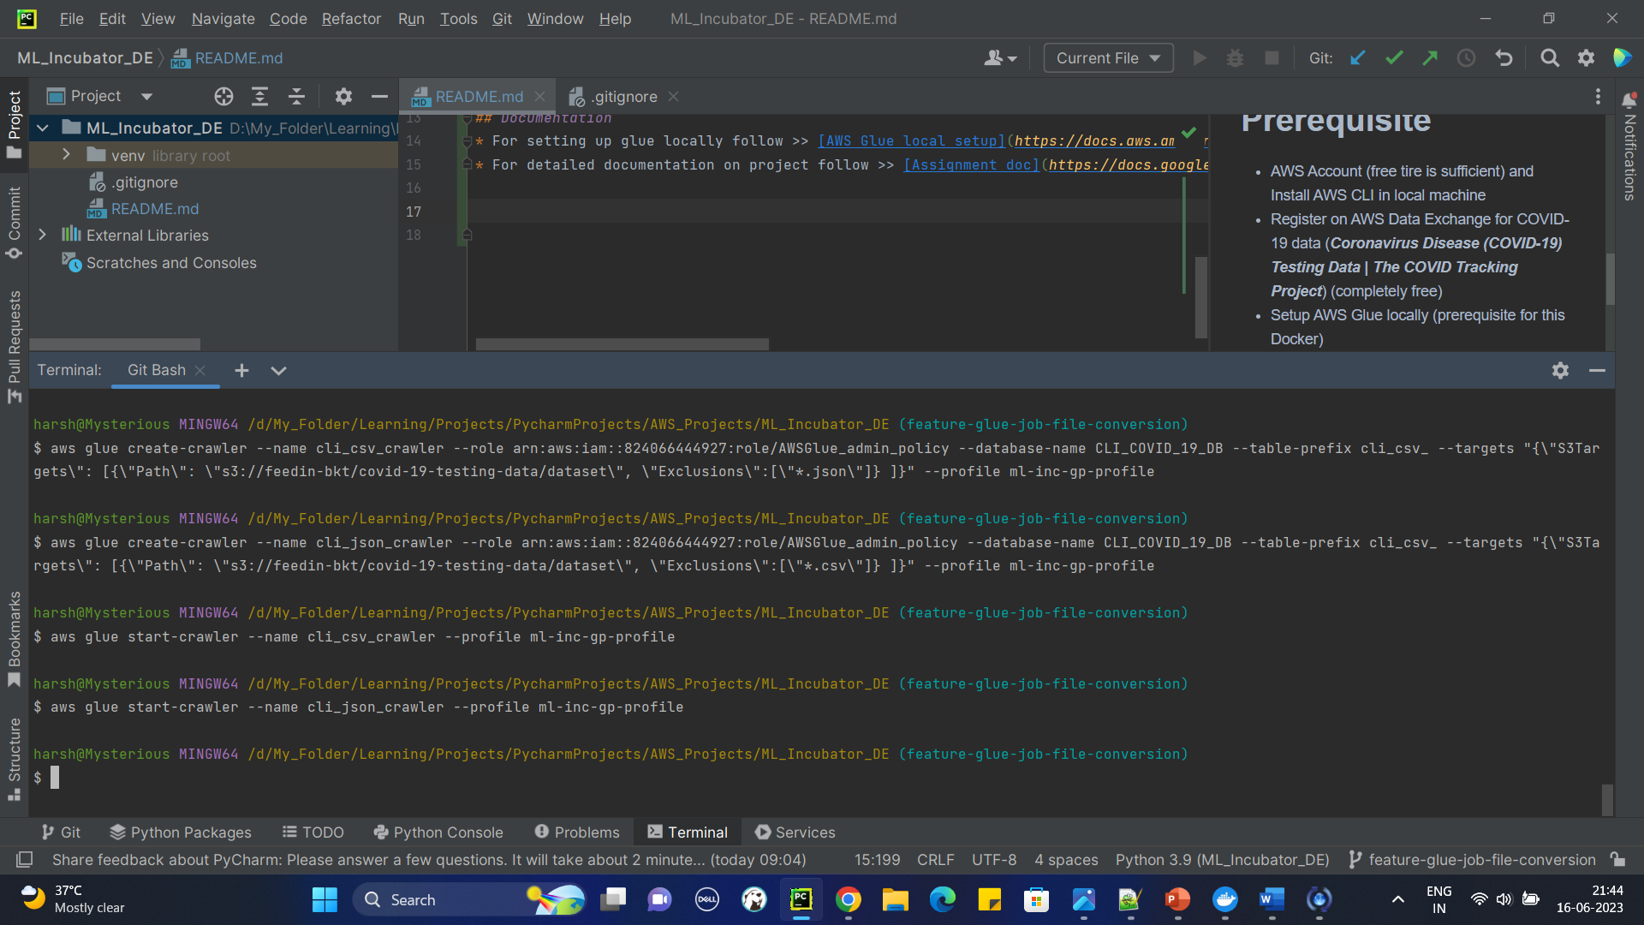

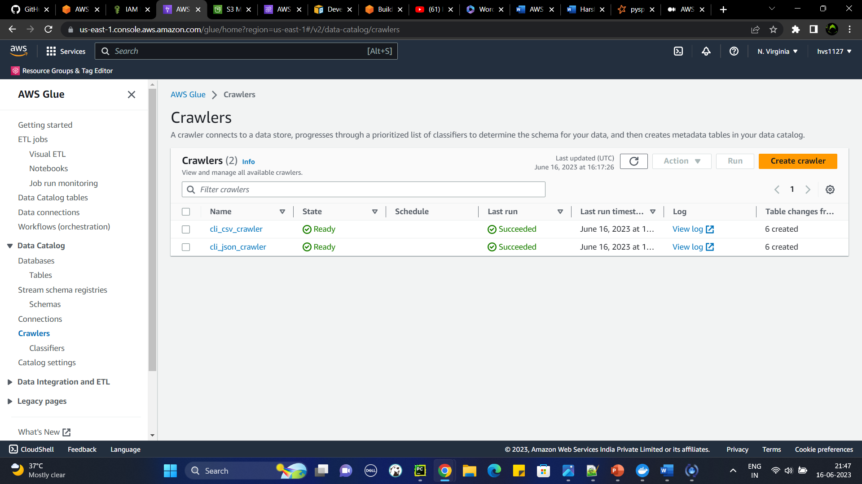

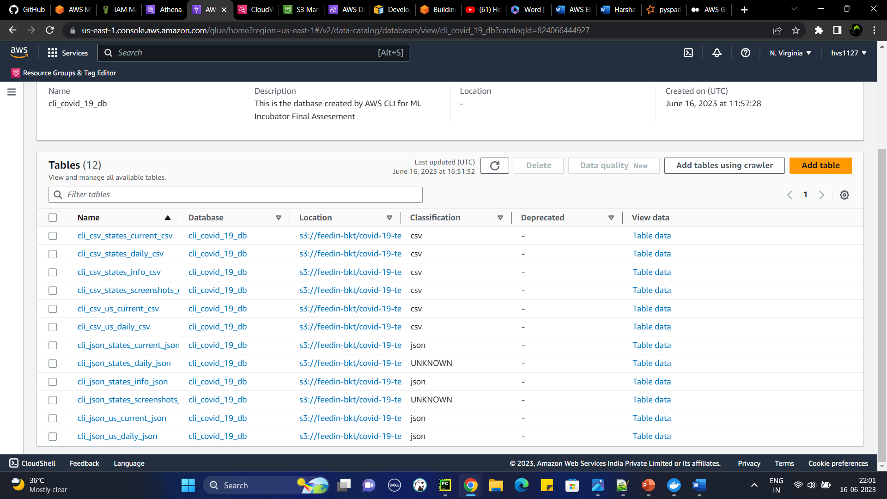

***Note: For two of the table's while crawling from json file classification shows UNKNOWN***

1. Confirm the data has been able to query from Athena.

I am unable to query data, from all the tables when I query, I get zero records.

After long research over the internet, I found a solution that for each file with different schema need to be created into different folders.

Article followed: <https://repost.aws/knowledge-center/athena-empty-results>

(If there is any other solution, please do let me know)

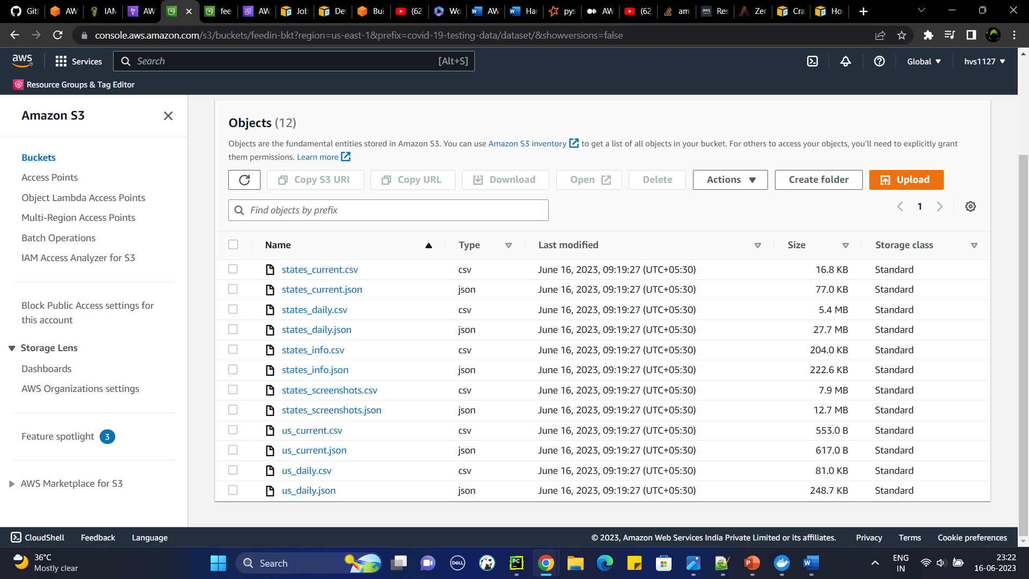

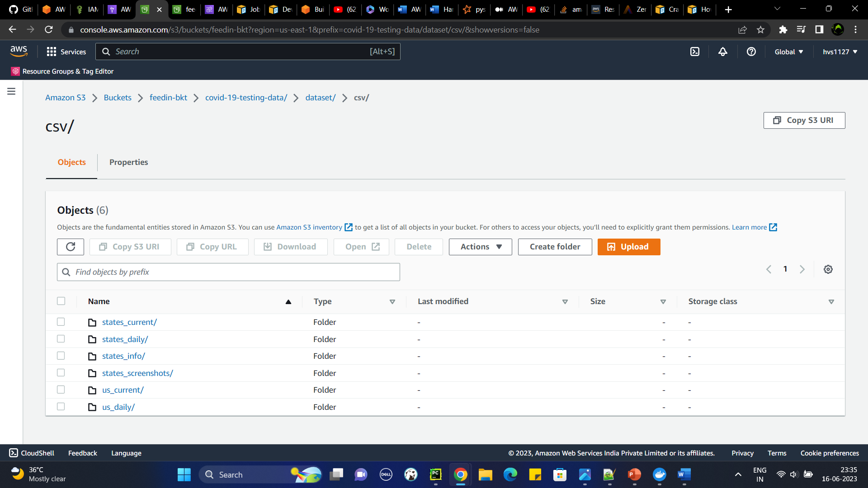

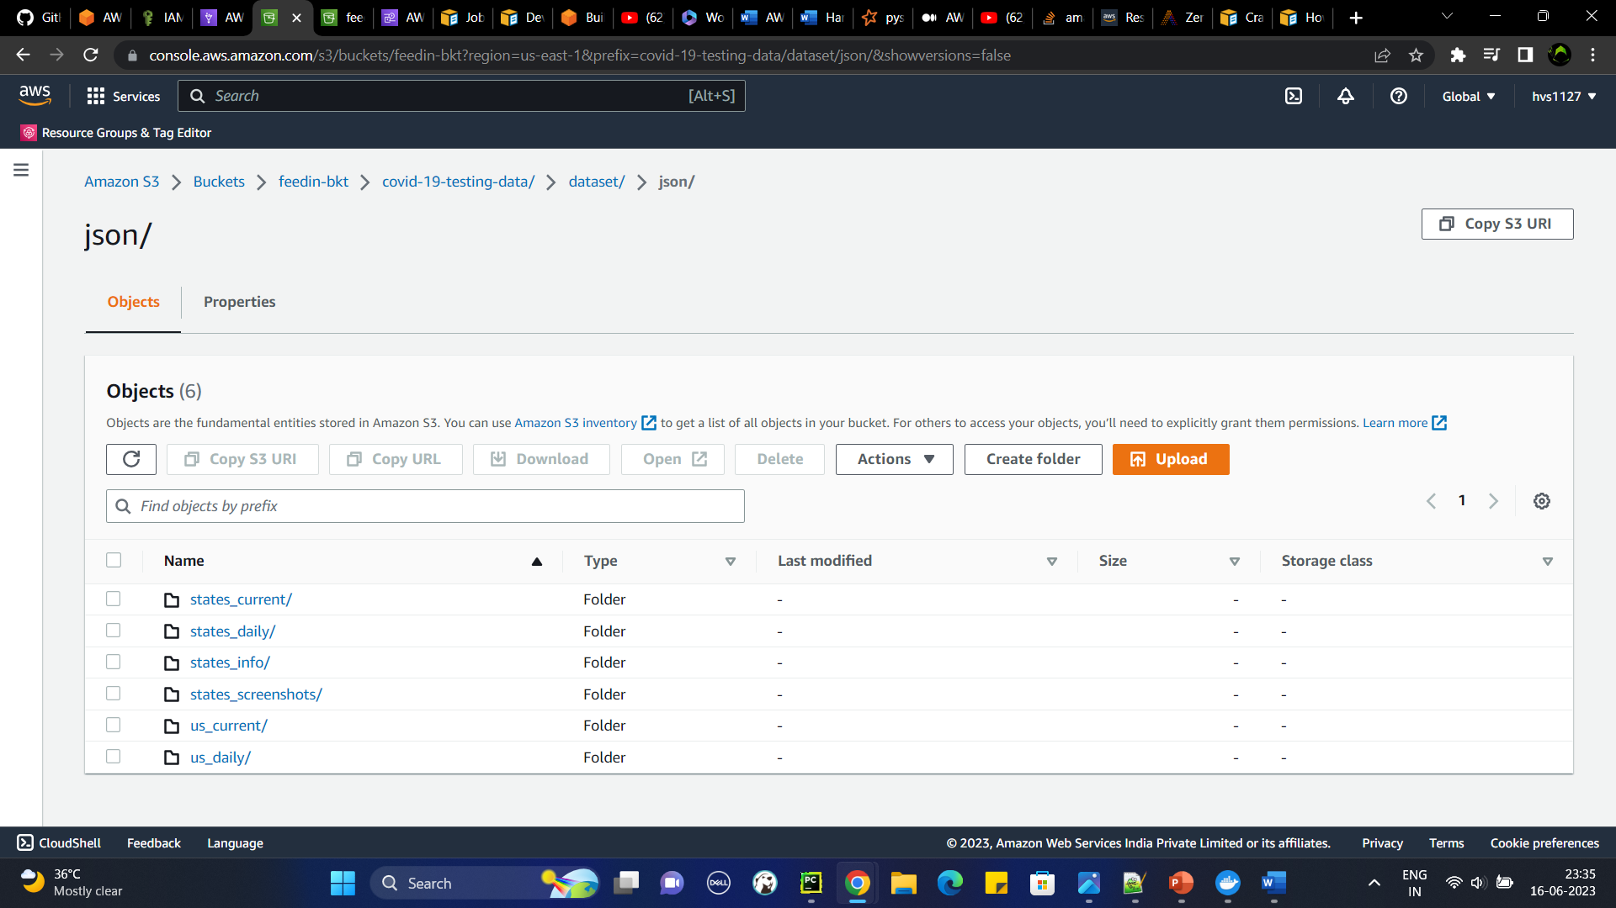

Deleting the database, recreating crawlers to crawl files.

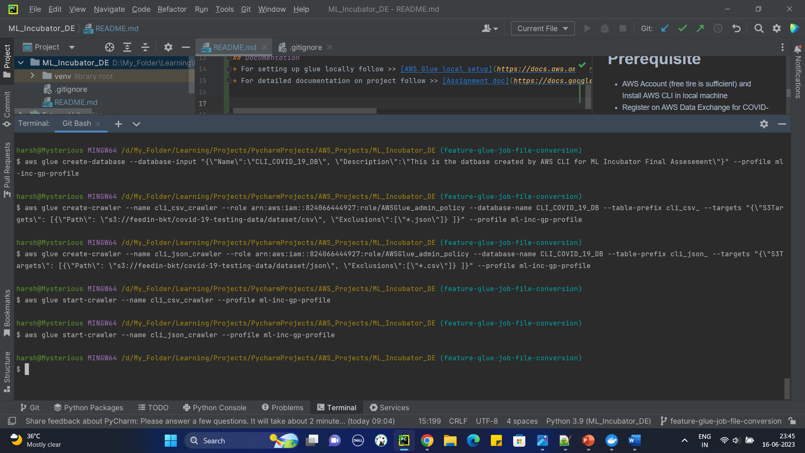

* This time all the csv table are created properly and able to query them but when it comes to json files, it created only one table and it treated all the schemas in different folder as one schema.
* Later I recreated the json crawler and passed each individual locations to S3Targets and it was able to create 6 different tables

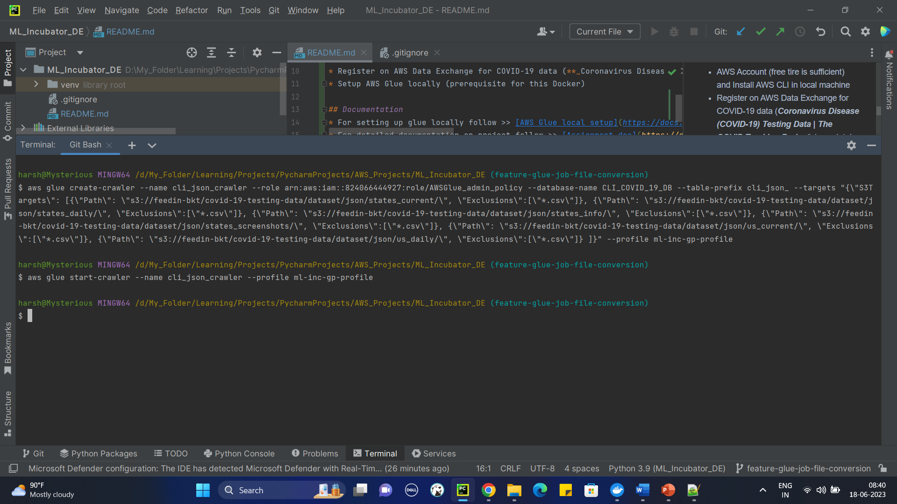

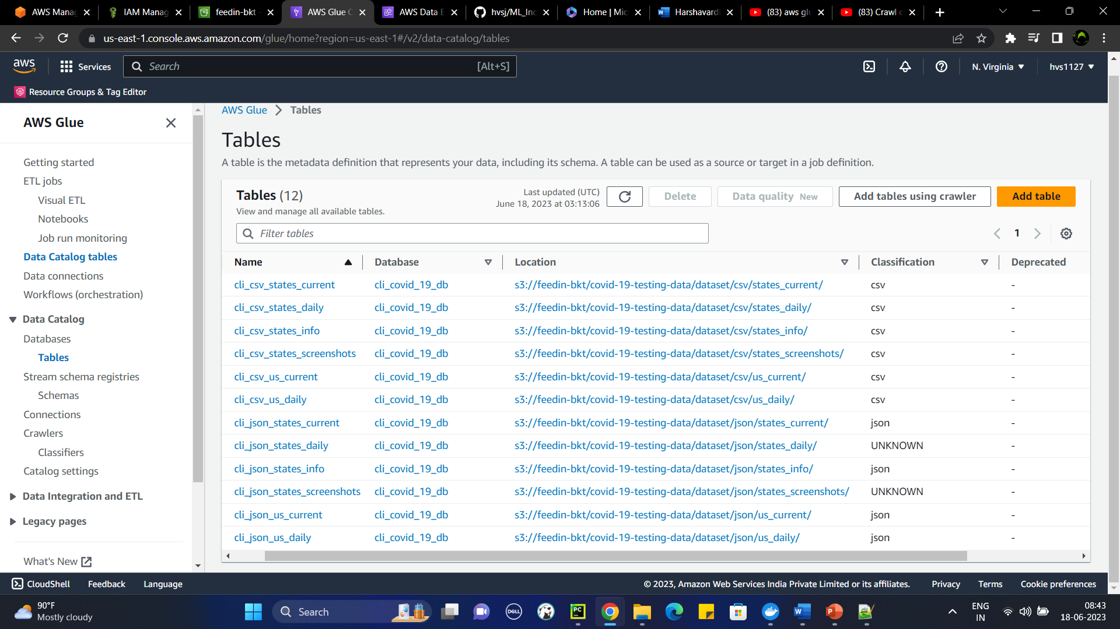

( Note: We can ignore cli_json_json table, I deleted it later)

1. Confirm the data has been able to query from Athena.

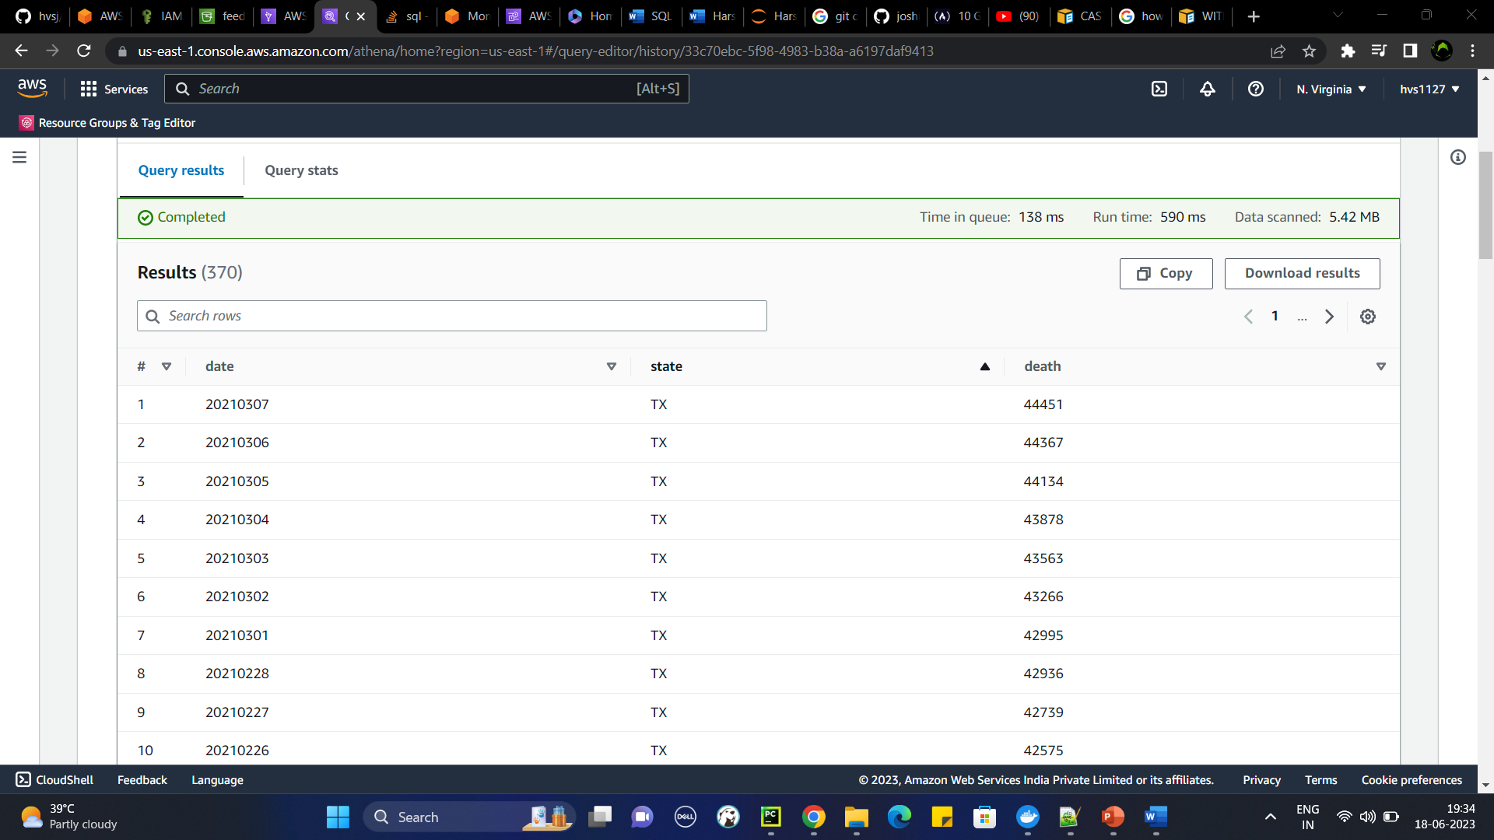

Task 2

1. Deploy GLUE locally and not use AWS GLUE. I have shared a walkthrough of this on Last class.

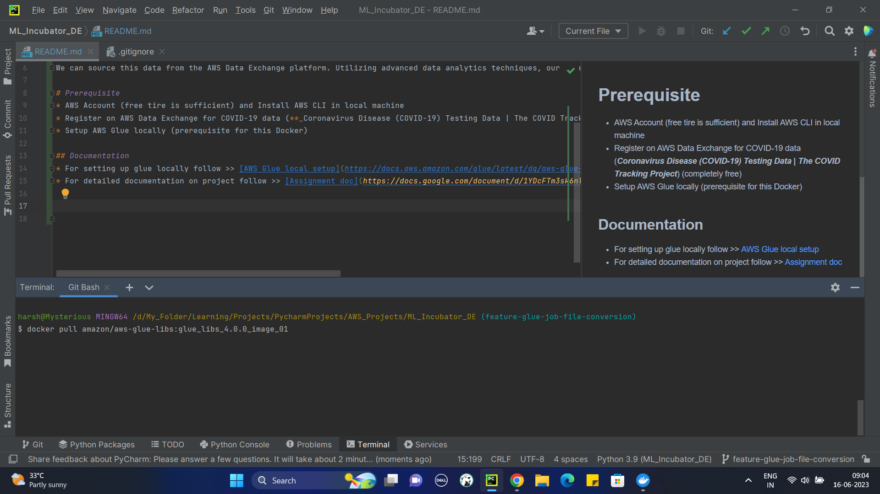

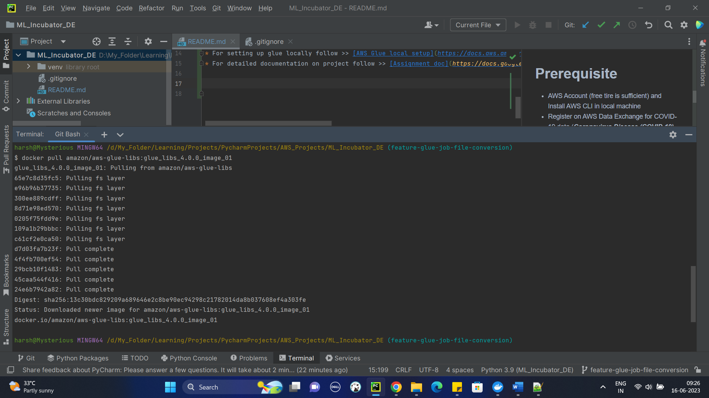

1. Develop a GLUE JOB to convert the CSV files to PARQUET from Local Development only (Do not use AWS GLUE Console). If there are memory limitations, then limit the dataset to 100 records only

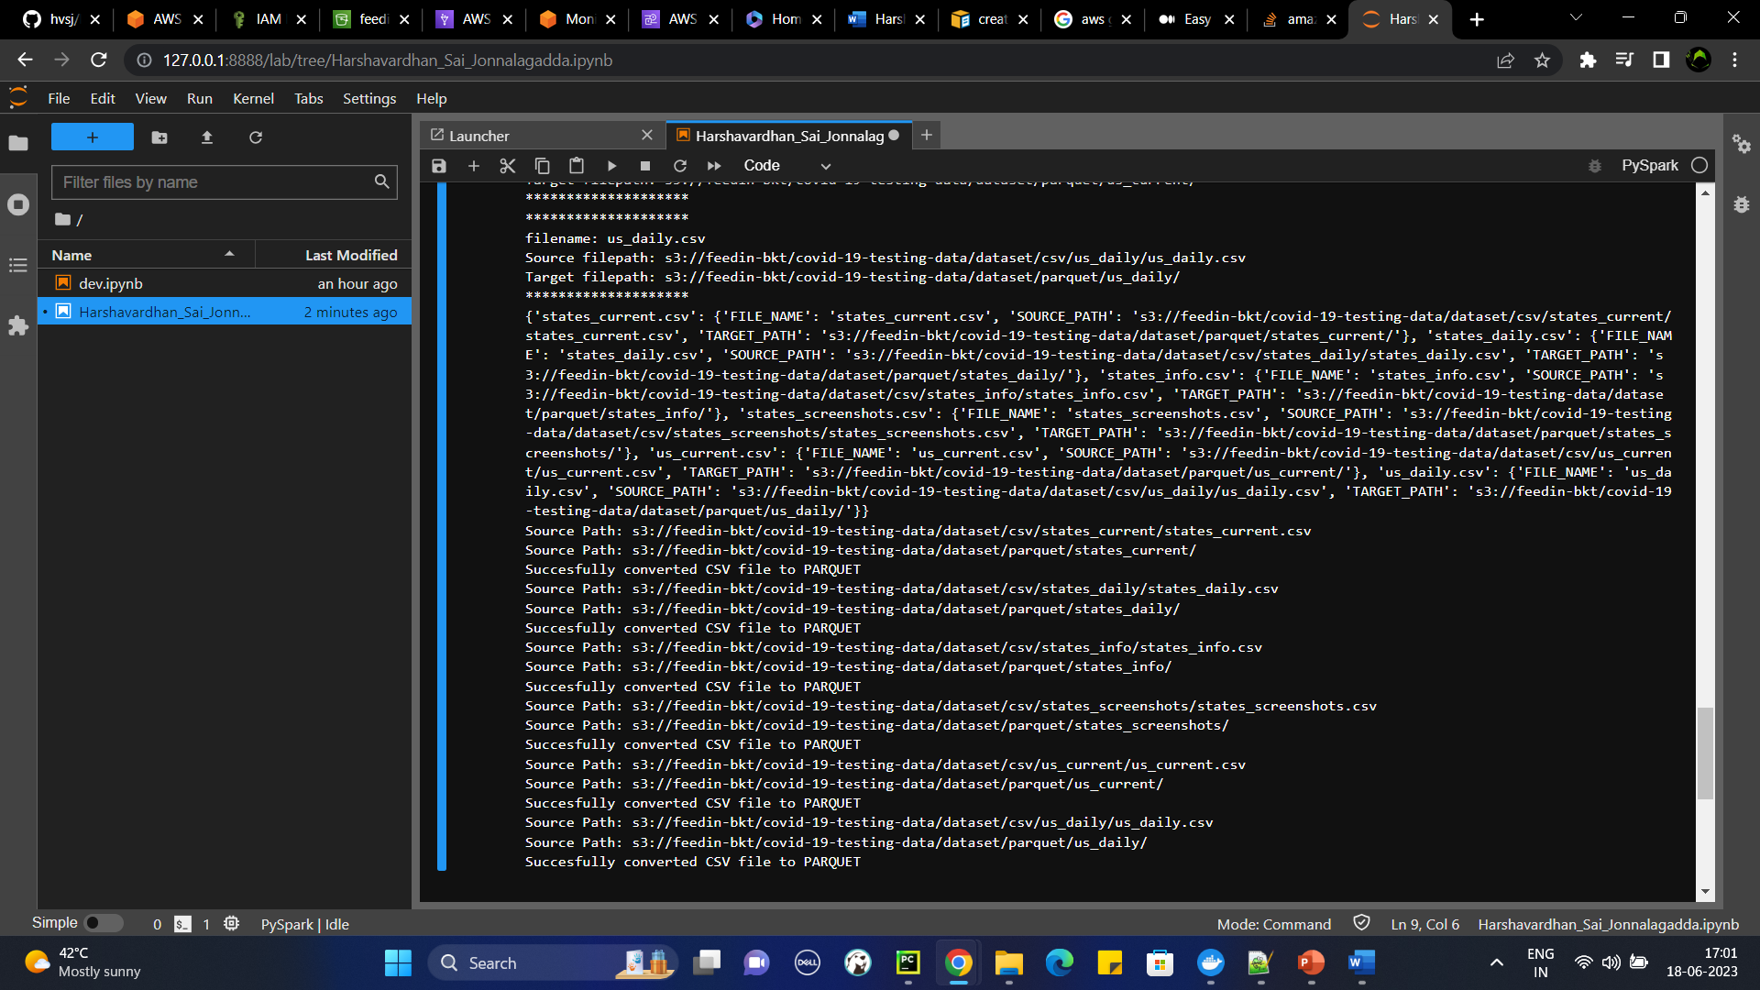

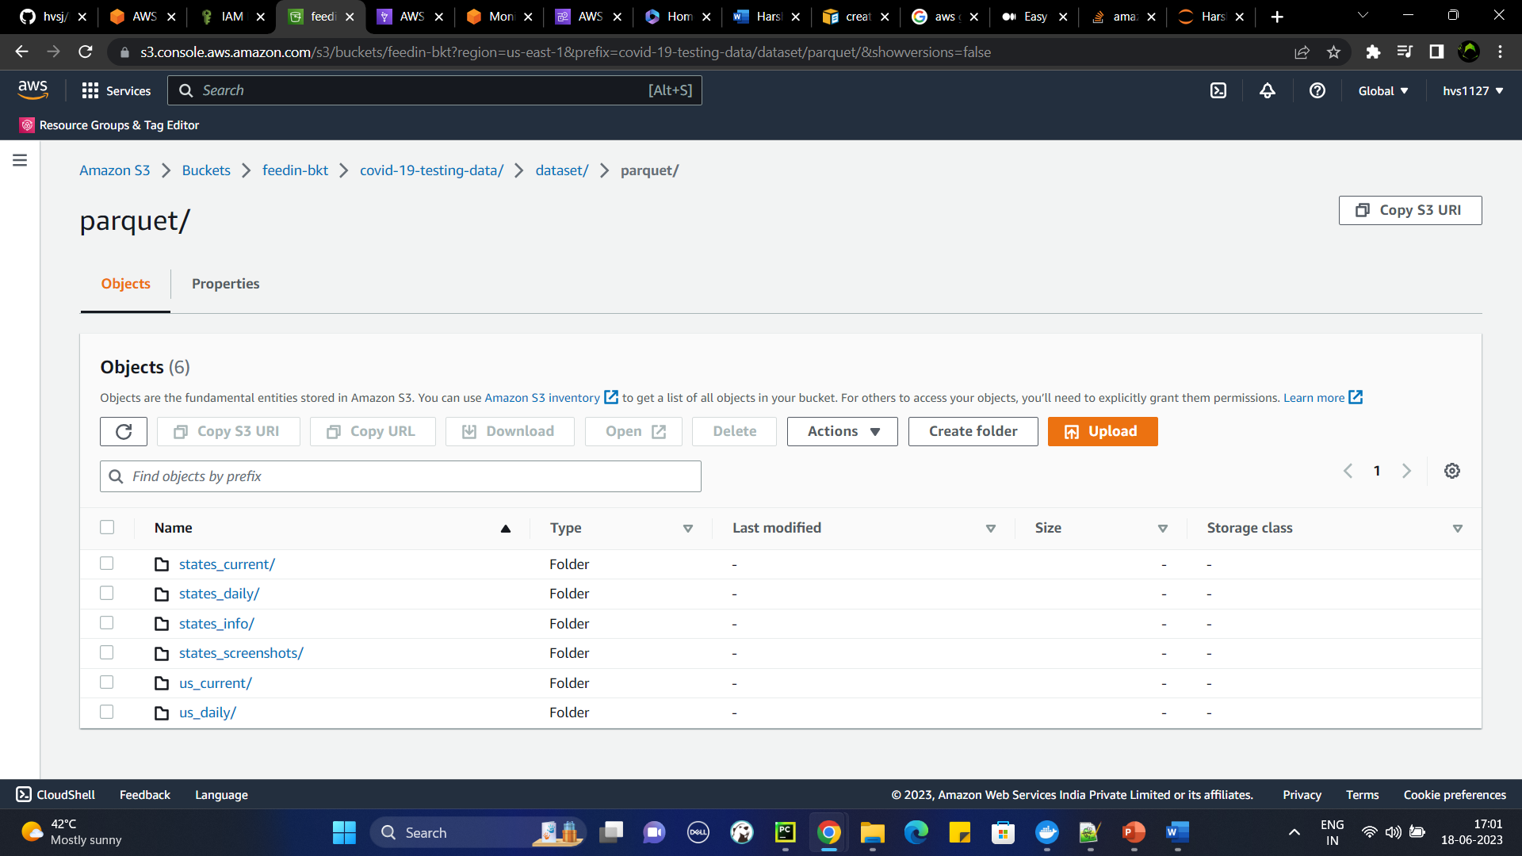

>> GitHub repository link -> **GITHUB REPOSITORY LINK:** [**GitHub**](https://github.com/hvsj/ML_Incubator_DE)

1. Create crawler using AWS CLI on the parquet file

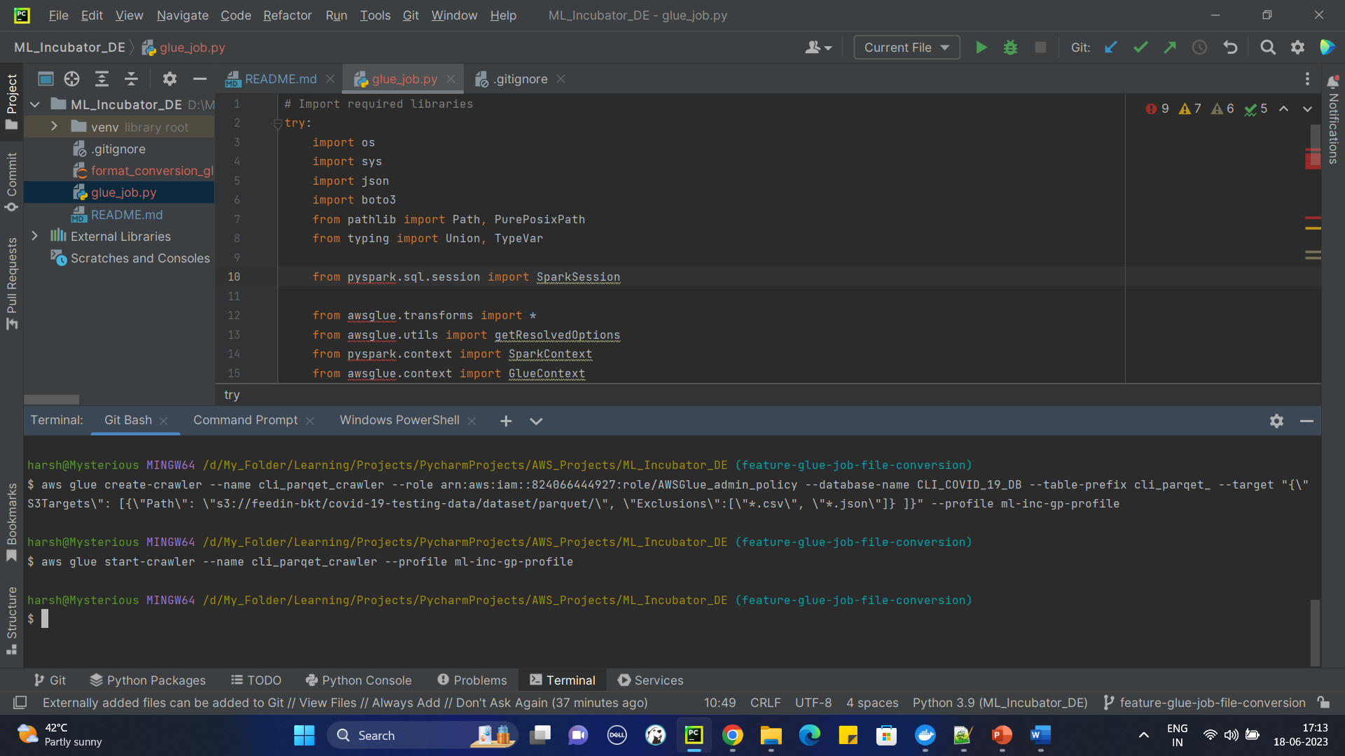

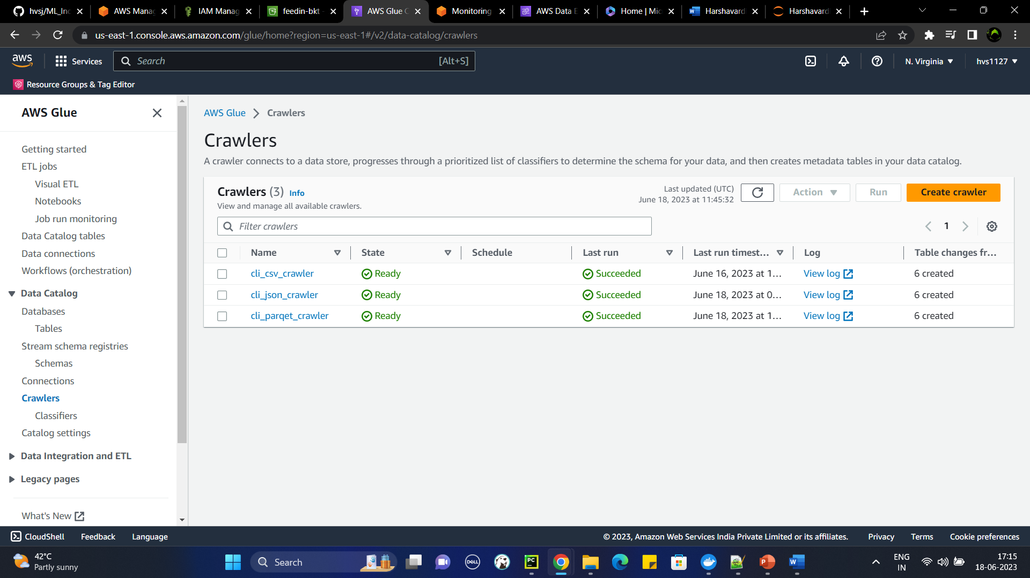

1. Run the crawler from CLI and confirm data from Athena

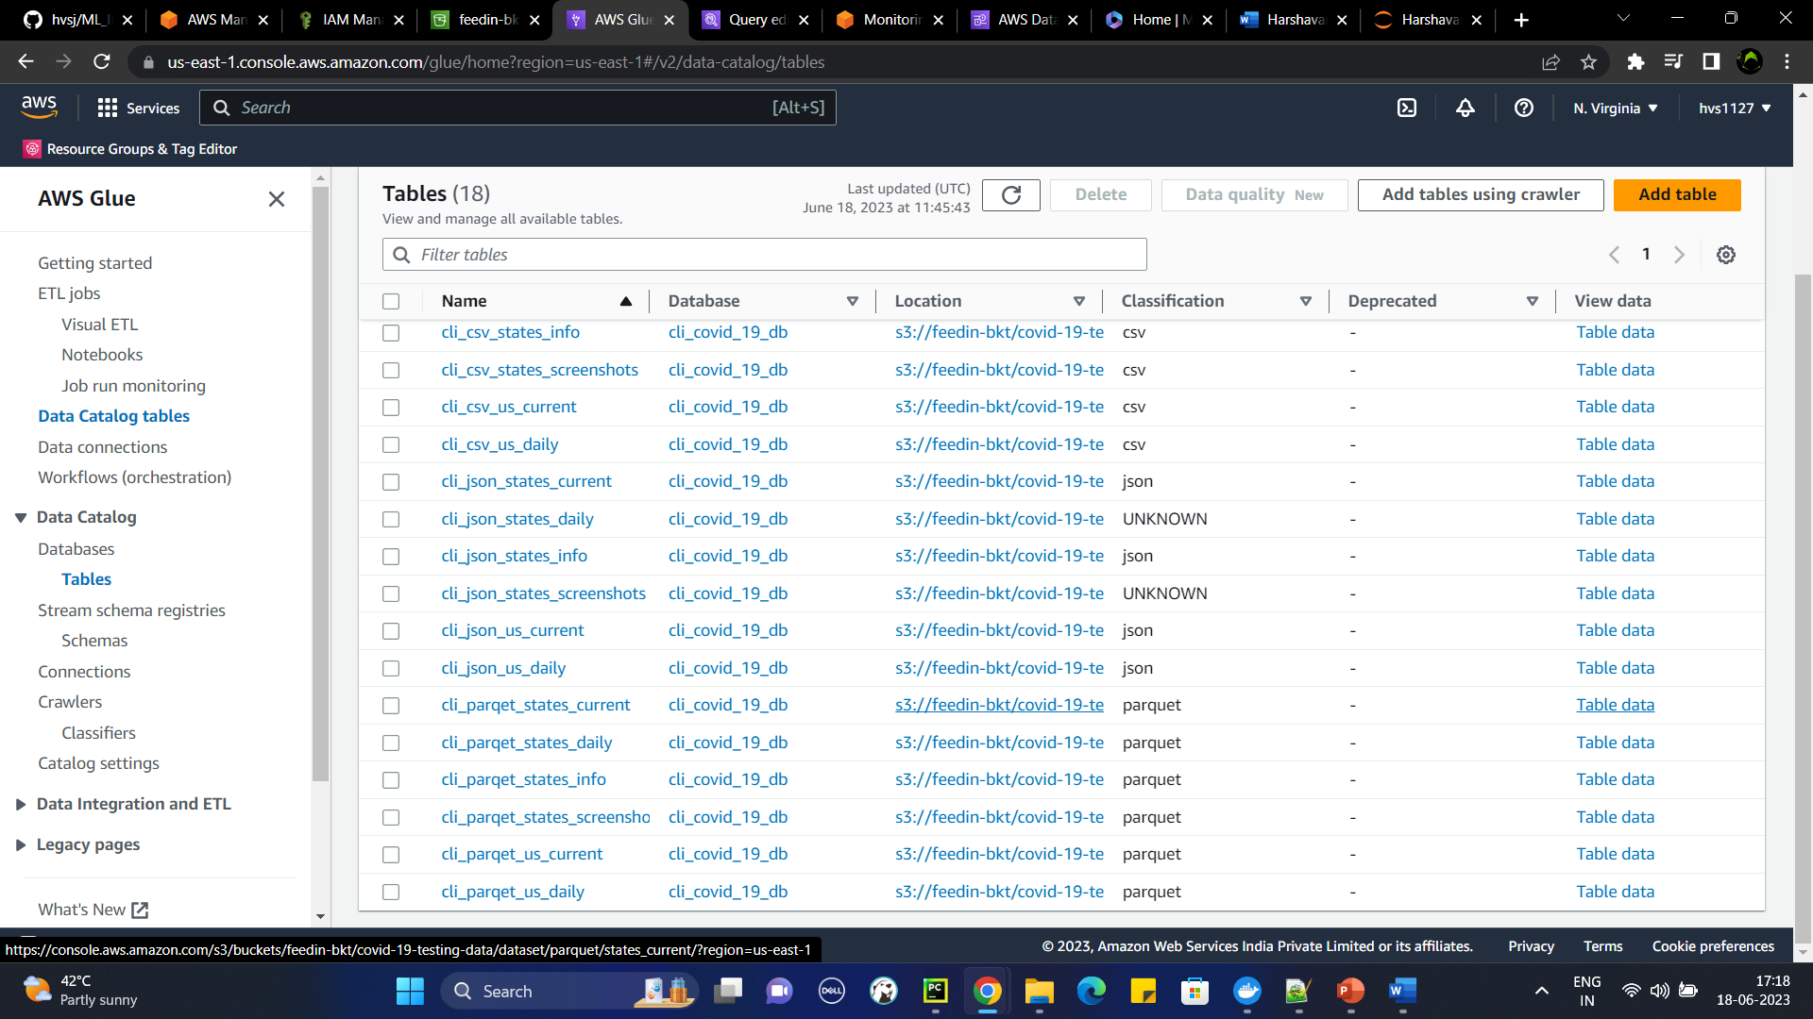

Task 3

1. Run basic Analytical queries on the dataset using Athena from AWS Console

**Data Versioning Task:**

**Task 1**

Create a repository in GitHub and upload the dataset

* 1. Create a repository in github.com

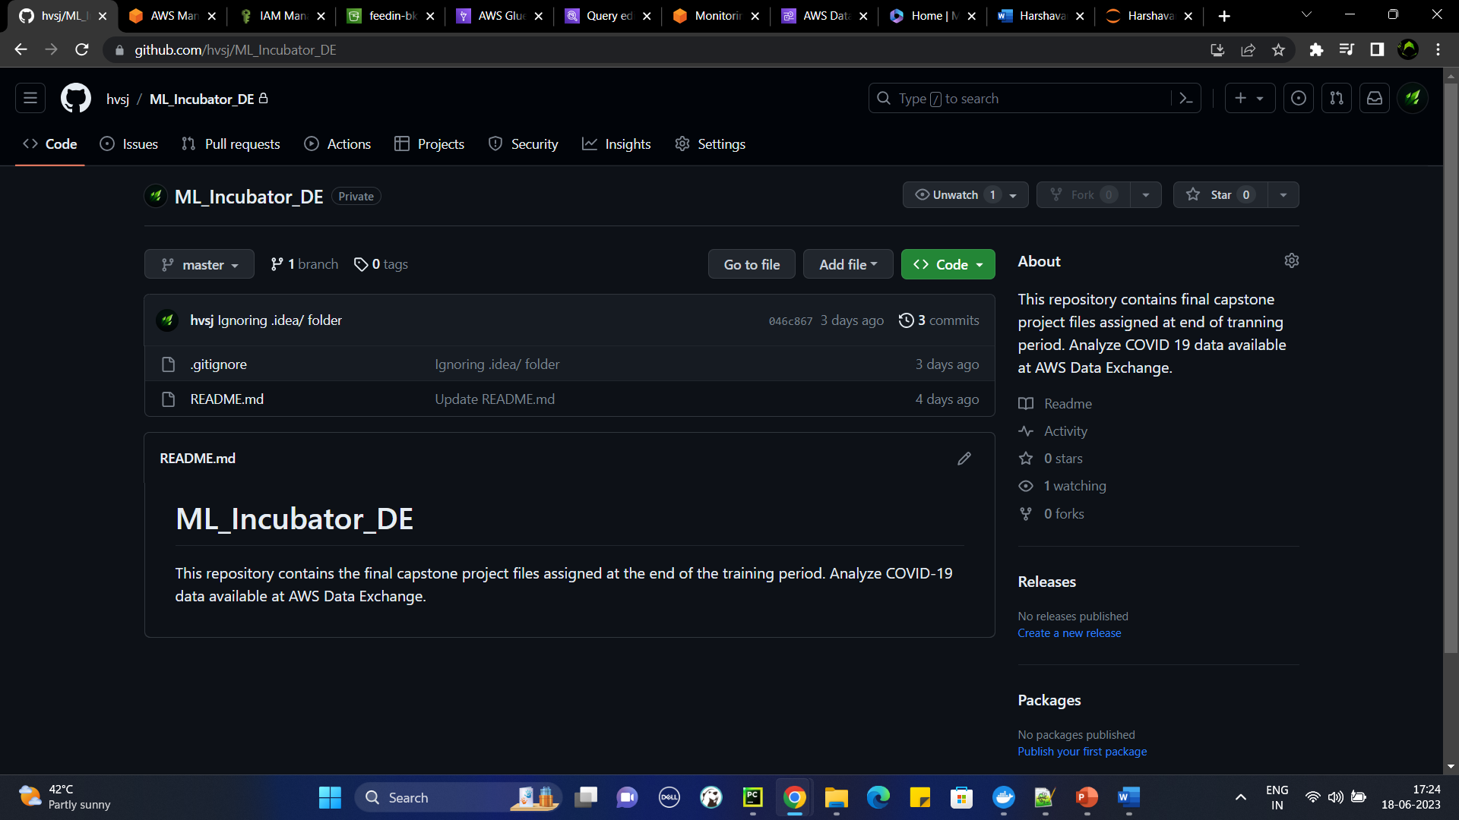

**Task 2**

Generate the Reports and upload them to GitHub

1. Clone the repository that you created in task 1.
2. Create a branch for this activity, create a file with all the queries from the above tasks. **branch (feature-final-doc)**

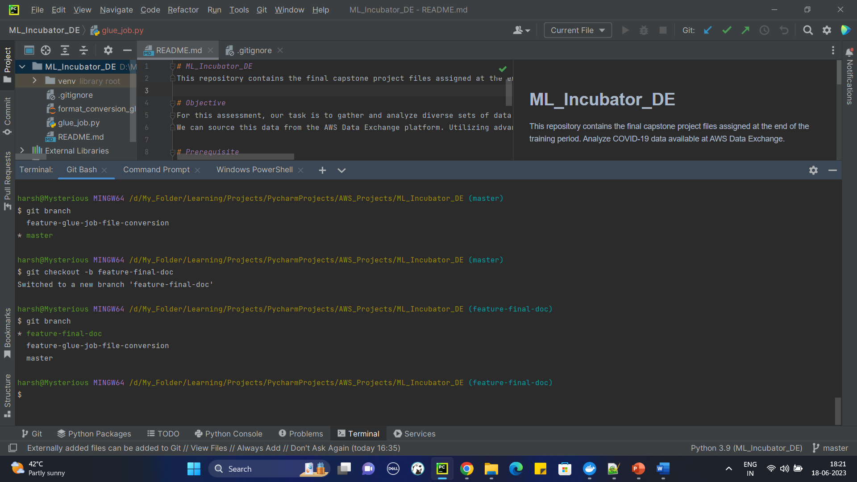

1. List the version history (commit history), status of the local repository

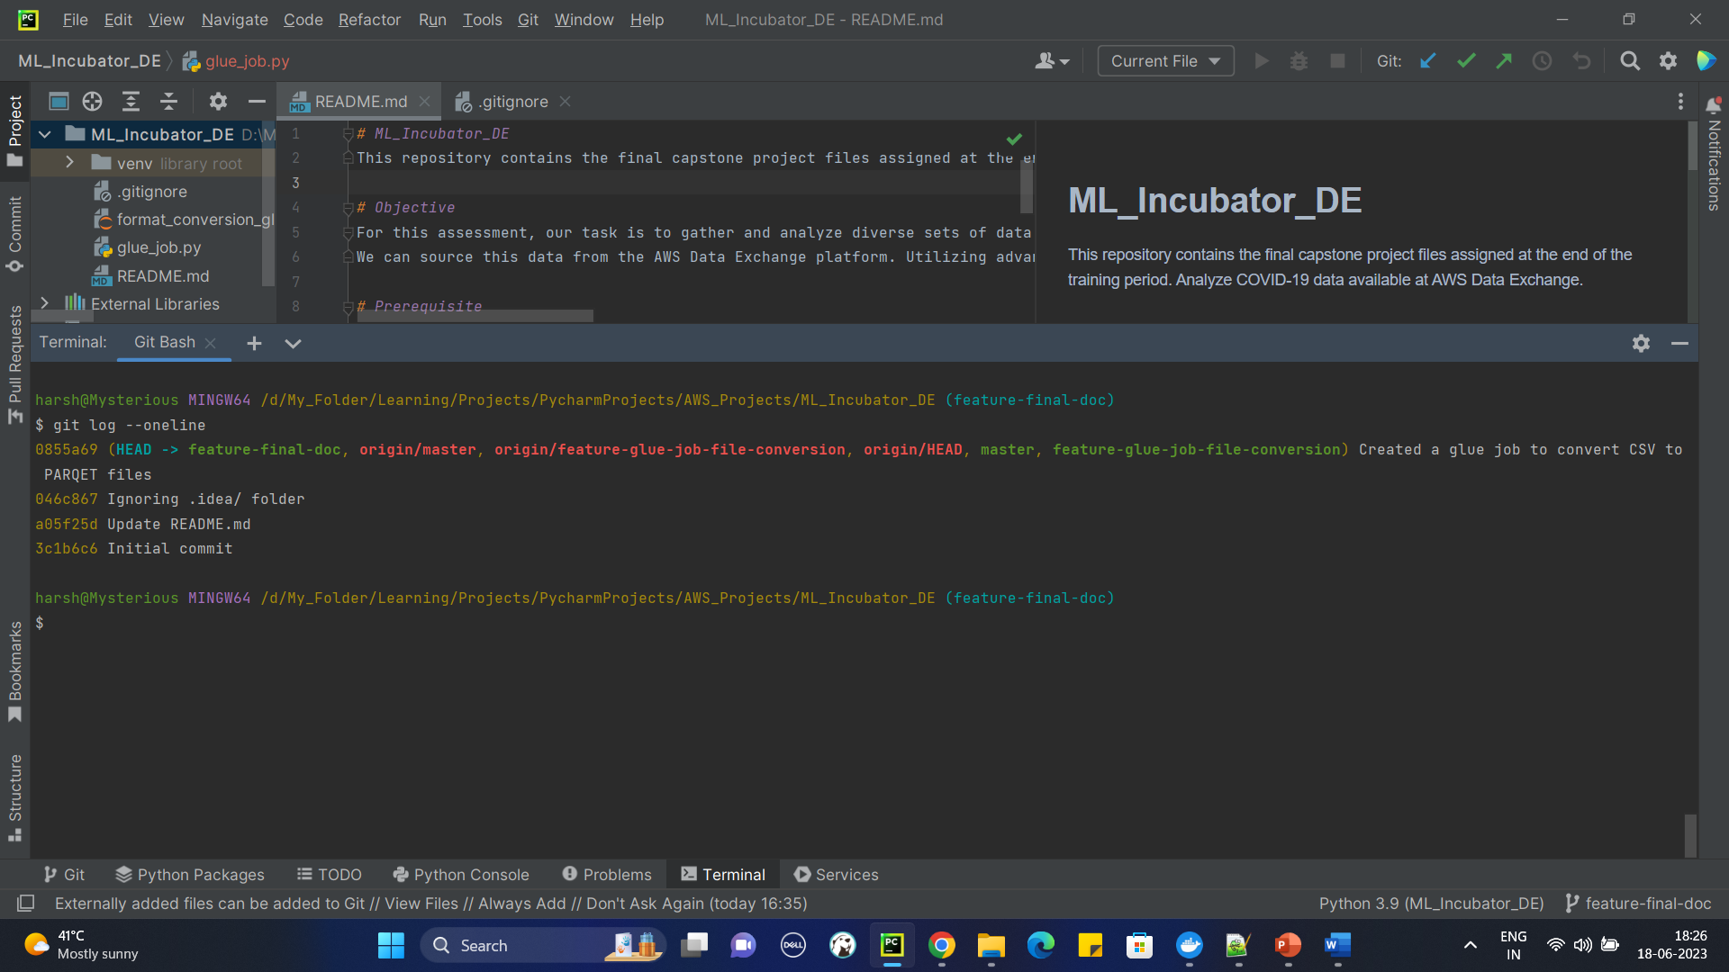

1. Commit the file to the branch

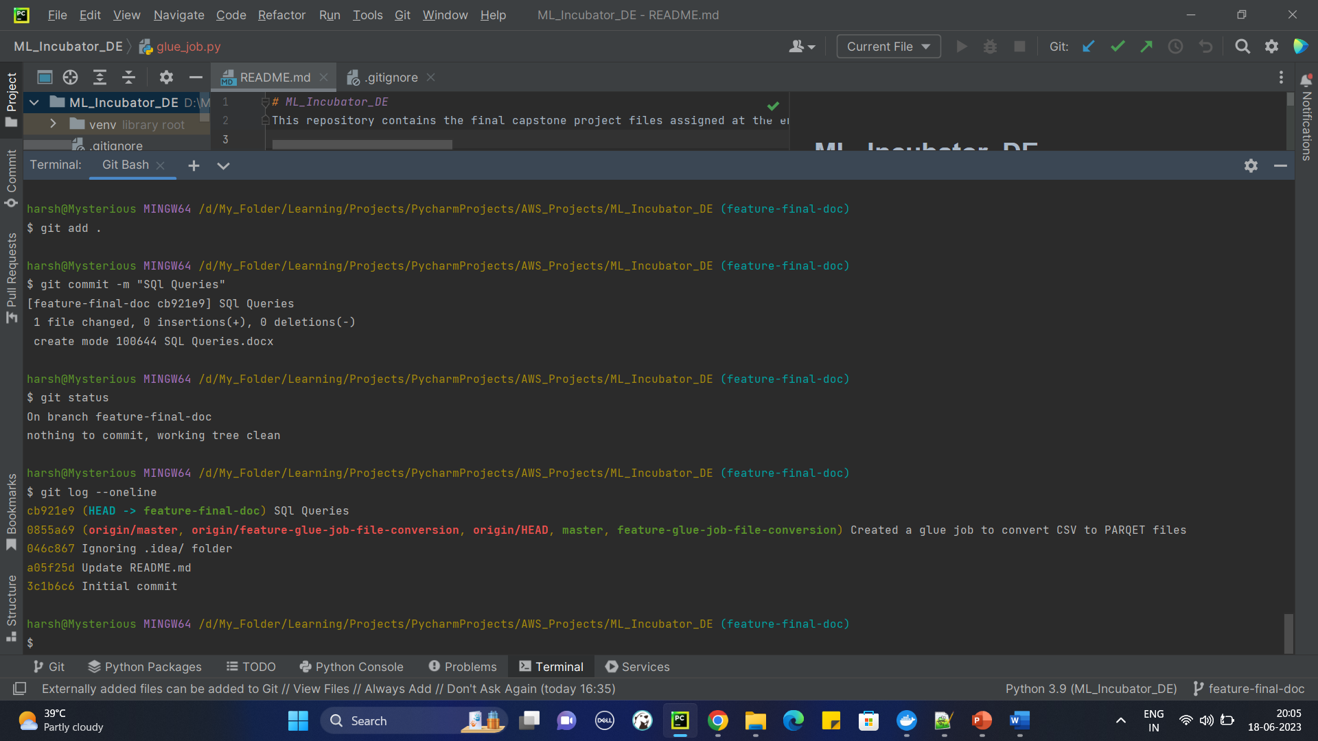

1. Push the changes to the GitHub

